Game Design C17870 Game Design Document Trump Escape/ Land of the Free Thomas Simmons K1906250

Module Leaders: Hope Caton & Jarek Francik

Introduction 3

Intended Game Platforms 3

Target Market and Players: 4

Game Logo: 4

Game Progression and Flow Chart: 5

Progression System 5

Player Challenges 5

Boss Battles 6

Game Outline: 7

Game Story: 7

Backstory Cut Scene: 7

Donald Trump’s Story: 8

Beginning: 8

The Defence of the White House: 8

Liberation of Washington DC 8

Further Main Missions: 8

Variation in Play 8

Trump End Game 9

Hillary Clintons Starting Story Ark 10

Beginning: 10

Further Main Missions 10

Variation in play: 10

Clinton End Game: 11

Barack Obama’s Starting Story Ark 12

Country Divided 12

Variation in play: 12

Obama Endgame: 13

Game Characters and Traits: 14

Playable Characters (PC’s) and Traits: 14

Donald Trump: 14

Hillary and Bill Clinton: 15

Barack & Michelle Obama: 16

Non-Playable Characters (NPC’s): 17

Player Character Customisation 19

Beginning of the Game: 19

During Walkthrough of the Game: 19

Gameplay: 20

Sequence of Play after Intro: 20

Different Scenarios: 20

Collectables & Pick Ups: 20

Game World: 21

Game World Map: 21

Features of World Map: 22

Environments and Locations: 22

Story Related Locations: 22

Character Specific Locations: 23

Things found in Different Environments: 23

Audio and Soundtrack Features: 23

Character Speech: 23

Different Scenarios, Winning or Losing: 24

Environments: 24

Game Experience: 25

Player First Impressions: 25

Development of the Player Character: 25

Story Cut Scenes: 25

Gameplay Mechanics: 26

Core Mechanics: 26

Interacting Mechanics: 26

Economy Mechanics: 26

Encounters: 27

Achievements: 27

Bonus Material: 27

Monetization: 28

In Game Store: 28

Downloadable Content (DLC): 28

# Introduction

This game is based on a possible near future America, where president Trump only has a few months in office remaining and his opposition are trying to impeach him.

The game starts with a video clip of president Trump taking a call from someone threatening to expose him, with evidence that the Russians helped him get into office in 2016 and stating they have physical proof and witnesses willing to testify. The president is seen to respond angrily shouting down the phone to the unknown caller and hangs up.

The clip then moves on to a few months later where the threats have become real and the information about Donald’s use of the Russians becomes public for everyone to see, which is where the game starts. After watching this video the player has the choice to play as Donald, Hillary or Barack, with the story ark they will follow dependant on which character they chose.

## Intended Game Platforms

The intended platforms for this game are the most common smartphones and consoles, such as but not limited to Apple, Android, Windows PC, Xbox and PlayStation. With Microsoft exiting the mobile market its mobile device is not seen as relevant at this time.

This broad stroke approach is based on the estimated growth in the mobile and consoles markets to $68.5 billion and $48.9 billion respectively, along with the estimate that 75% of people who use both for their game play,15% being causal or tablet gamers This is shown as shown on figures 1-4 below.

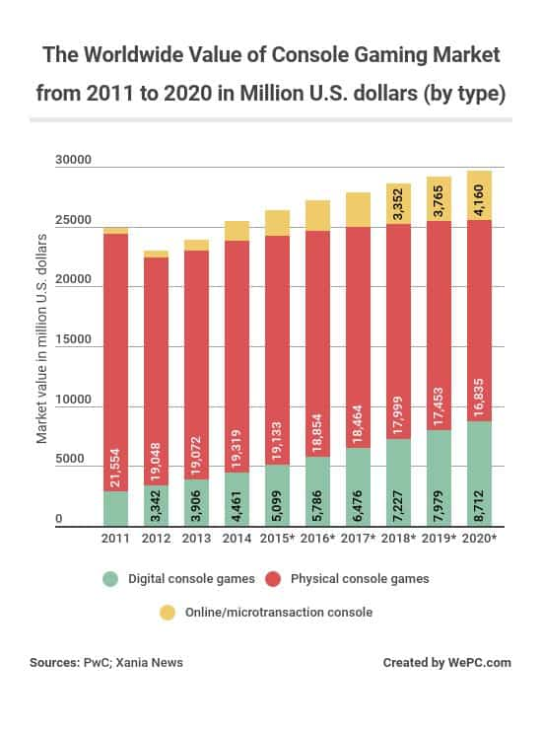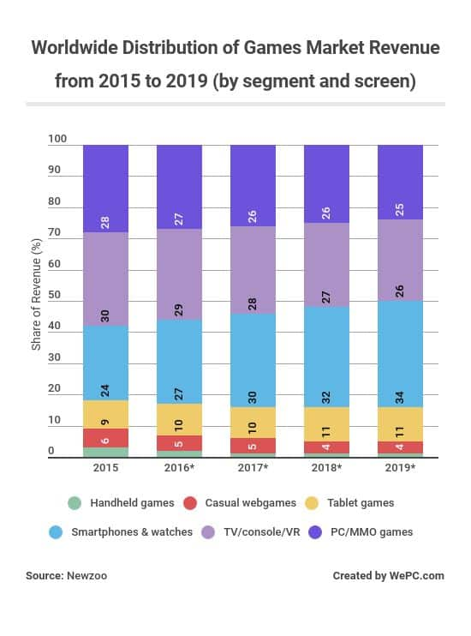



[](https://www.google.co.uk/url?sa=i&rct=j&q=&esrc=s&source=images&cd=&cad=rja&uact=8&ved=2ahUKEwi-3OPfmJfnAhXSxYUKHZsDC9cQjRx6BAgBEAQ&url=https://www.gamingfeature.com/video-game-statistics/&psig=AOvVaw2h0u8LEhwyxWFar5we6e2s&ust=1579781975365842)

Figures 1 2 3 & 4

## Target Market and Players:

The game will be aimed at:

* The 16+ age group, due to the high level of violence, moderate use of bad language, references towards discrimination and drug usage but including theoretical events (figure 5).
* Players who are into single player 3rd person role playing games where they are allowed to customise their character, has a great story and topical back story behind it.

Whilst the genre will be very important, the concept has been conceived to appeal to all types of players such as tactical, explorer and social, with the involvement of humour which will help gather players who just want to mess about on games.   
For the players who do not take to the game due to its USA story line, they’re going to be future expansions of the game scenario to include other topical political tensions, such as Brexit, Catalonia, South America etc, along with references towards other real world scenarios will help draw in players who watch the news or use social media on a regular basis.



Figure 5

## Game Logo:

Figure 5 is the suggested game logo. The idea is based on current games such has mortal combat where two of the most iconic characters face off against each other, this is also the case for movies such as Creed (Boxing Movie) and Assassins Creed. For this game the three main characters are Trump, Clinton and Obama. The USA is in the background to tell the player where the battleground will be with each state coloured to represent who’s in charge.

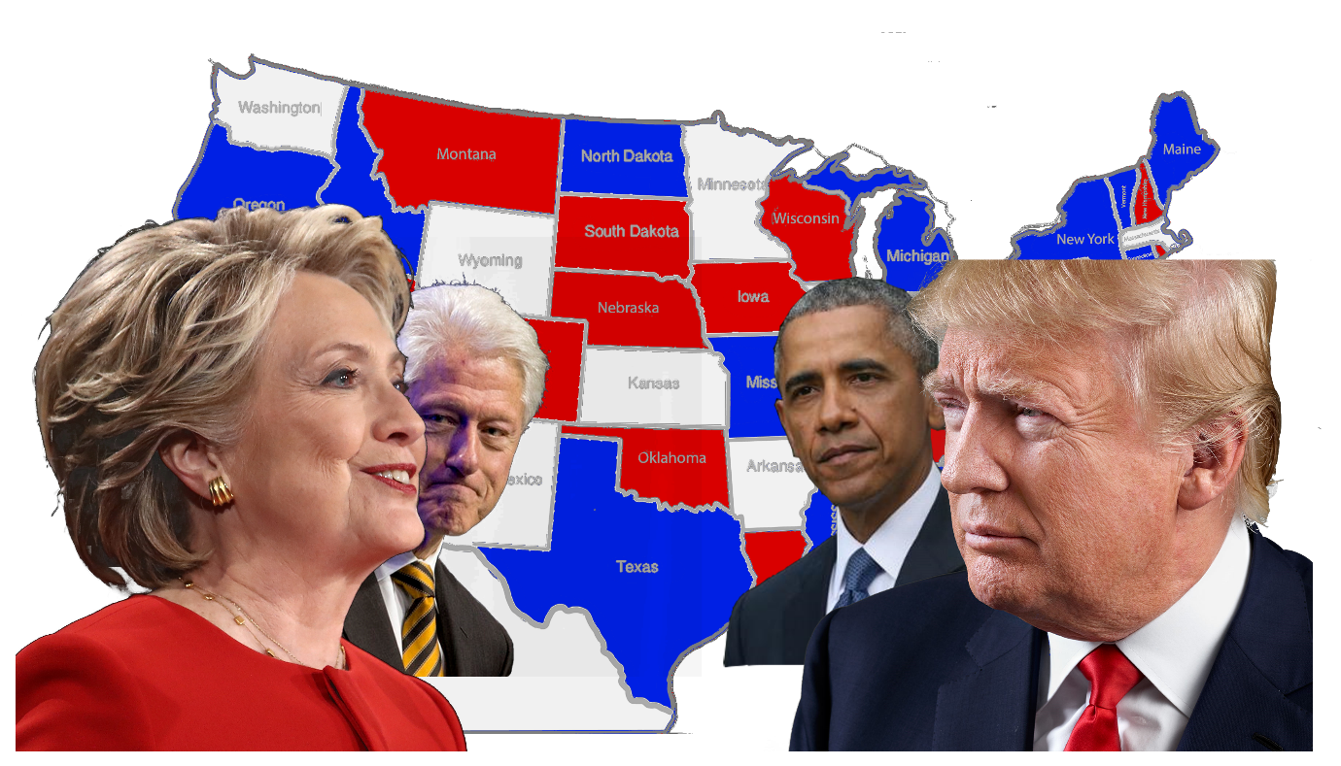

Figure 6

# Game Progression and Flow Chart:

## Progression System

The game starts with an opening video clip explaining the USA scenario, a future enhancement would allow a player to select difference scenarios with different charterers.

After watching the initial video the player chooses the character they wish to play as and is then tasked with completing main story missions, side missions and activities in each state or city.

These missions and activities will help them acquire influence and power to control each state and city, with each state having a progress bar showing the current influence the player has won with rewards earned by the player at milestones such as 30%, 60%, 80% and 100% influence for each state.

Players are rewarded with experience points which helps towards levelling up their character in the game. Also earned in game currency enabling them to buy general or mission specific equipment from in game shops scattered across the map.

They can also earn or win equipment, armour, influence and health respective of their current traits, goals and what character they are playing as. The rarity of the equipment earned being determined by the player’s performance and difficulty.

The player is also capable of opening loot crates of different sizes and rarity for loyal gameplay such as amount of hours played, completing several missions and activities and specifically for mobile players the opportunity to watch advertisement videos. In these loot crates players can find common rewards such as extra experience, currency and basic equipment to rarer or legendary rewards such as high amounts of experience, currency, weaponry and boosts or buffs.

## Player Challenges

During gameplay the player will encounter several different challenges where their options on how to deal with them being influenced by the character they have chosen, thus the player will need to adapt to each different situation in order to achieve the required objective.

This can be in a main or side story mission, or an activity to help nudge the political influence in that state in the players’ parties favour, and will earn extra rewards and buffs which will help the player directly.

The player will also have to manage the states they acquire during the campaign by spending time in them, which leaves them less time elsewhere, this requires strategy on the part of the player, as if they leave it for too long they risk losing state influence and possibly the state itself, resulting in the loss of the rewards, currency and experience they earned when they acquired it.

If the player wants those rewards back or simply is a player who wants to complete 100% of the game as an ‘achievement hunter’ they will have to go back to that state and complete or recomplete the side missions and activities taken by their enemies. Players will not need to complete the main story mission again.

## Boss Battles

The bosses of each state and cities are governors or political assets from enemy factions. The governors are equipped with weapons and equipment relevant to the party they are with. For example if they are with Trump they will have powerful offensive weapons and if defeated have more offensive rewards over others.

If the player is able to kill or capture a boss, depending on who they play as they win the rewards held by the them as well as a major boost in state influence which could mean the player can earn more rewards, or win the state with this one action.

Missions and activities are graded, with some considerably harder than others, and some areas having no respawn areas, meaning the player will need to start the mission again if killed.

All of this is shown in the progression chart below on figure 7.

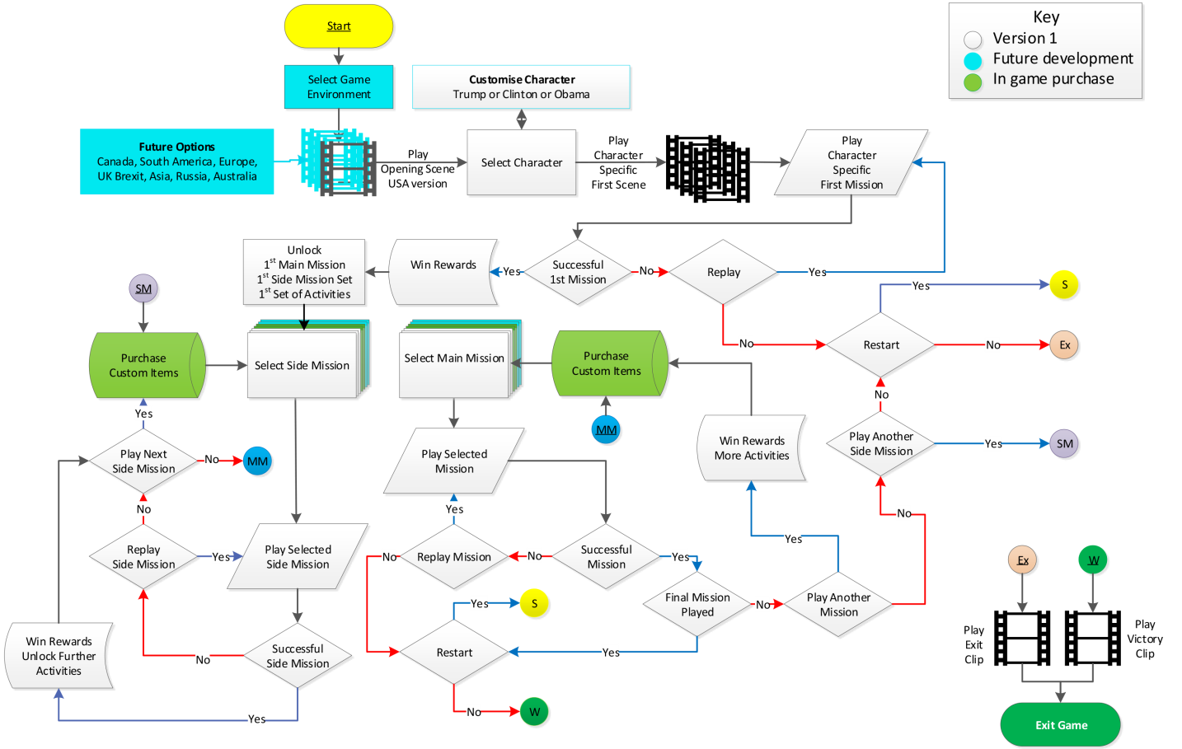

Figure 7

# Game Outline:

## Game Story:

The player has the opportunity to play as one of three political characters when they start the game; these characters are Donald Trump, Hillary Clinton or Barack Obama. All three playable characters have their own story arks and encounter each other at least once in their quest to control America.

At the beginning of the game the player watches a two minute opening backstory cut scene which shows them what has happened prior to the start of the game.

After this scene the player then gets the opportunity to choose the character they want to play as. If Donald Trump is selected they start by defending the white house, if Hillary Clinton is chosen they start as a Clinton soldier attacking the White House and if Barak Obama is chosen they start at home far away from the destruction of Washington DC gathering support and awareness.

## Backstory Cut Scene:

Donald Trump has just finished taking a very long and important call which ends in some very foul language with clear expressions of anger. His family and the Director of the Secret Service ask what is wrong, who was on the phone and what was discussed? Trump responds to his family that everything is okay and pulls the director into a private room.

Trump tells the director that his opponents have allegations about him using the Russians whist campaigning for president in 2016 and have witnesses as well as papers to prove this, which will gravely assist in his impeachment. They have threatened to make this information public unless he leaves office immediately. Donald lets the director know his opinion on the matter and how to proceed.

Near to his impeachment court date the documents and the witness’s statements are released making it 100% clear that the Russians helped Trump to come to power. America goes crazy and demands his impeachment.

Six months later America is in a state of civil war, divided along party lines with differing beliefs on how the country should be run and by whom, with the three main factions being those run by Barack Obama, Hillary Clinton and Donald Trump.

Resulting in the land of the free becoming a warzone.

# Donald Trump’s Story:

## Beginning:

The player having selected to play as Trump is introduced to the game world with him outfitted with a military grade standard assault rifle, side arm and body armour outside of the heavily damaged White House in Washington DC.

### The Defence of the White House:

The director of the secret service updates Trump on the defence of the White House. Trump then has to lead a defence against the attackers formed of city and state militia and political opposition in Washington DC. The goal being to prevent the occupation of the White House.

As the battle progresses the player as Trump must rally the defenders to successful hold back the attackers, if successful once the battle is over Donald investigates who the attackers were and who was in command, which then leads to the first main mission of the story.

### Liberation of Maryland State:

After saving the White House Trump takes his remaining forces to attack the main stronghold of his enemies in Washington DC. To succeed the player must complete a bloody battle before the stronghold is taken and occupied by Trumps forces.

After which the remaining resistance in DC is cleaned up via side missions, and the player moves onto the next main mission.

### Further Main Missions:

After the successful liberation of Washington DC and Maryland, Trump turns his interests to the neighbouring states and cities. At which point the player uses the forces acquired in previous levels to work their way from state to state, until all states have been won over and the game has been successfully completed, however during each mission variations of the game play based on how well resources have been used and retained come into play, which include but are not limited to the following:

## Variation in Play

### Risks of Early Successes:

If the early campaigning has been successful, Trump gets over confident in his chances of power in America once again, placing his most loyal commanders and representatives to keep the captured states under control. These successes encourage minor factions to join Trump without a fight however they are not treated as well as his own troops, causing small local uprisings which requires the player to keep returning to completed states to retain in complete control.

### Too rapid Expansion:

As Trump continues his expansion across America taking his army equipped with the latest equipment available from the military and other sources whist destroying, occupying or recruiting everything in his path. If this occurs to quickly the forces left behind will be made up of local National Guard, Police and Militia, who may turn against the player later in the game. To avoid this the player will need to negotiate treaties allowing the defeated leaders to keep some level of control, but that may act against him as well.

### Possible Political Decline:

Due to a lack of loyalists his army’s majority becomes composed of smaller factions and mercenaries feeding the start of their heads being turned to move against Trump. The player will have to choose how to react to anti Trump posters appearing in his controlled states, he can rip them down, and demands loyalty from his soldiers, allies and mercenaries, or negotiate to retain power, either approach may have implications, based on random number selection or resources etc.

### Major Defection of Allies:

Once the seeds of doubt has entered Trumps’ armies, the player has to manage his loyalists and advisors to continue with the expansion campaign, as the loss of a few states will only require the player to win them back, but if too many are lost a cascade effect will be triggered. Which results in Trump looking for a way to survive or escape.

### Plans to Escape America:

Trump plans to retake lands from the defectors resulting in the recapture of some states and cities however he finds himself fighting on too many fronts with limited troops and supplies so he is advised to strategically withdraw from his campaign and escape from America via Mexico.

### Loss of Remaining Allies:

Whist Trump and his squad move towards Mexico a large scale assault run by Clinton backed by Trump defectors on Trumps remaining allies. They have the orders to attempt to capture his wife and kids or kill Trump if possible.

# Trump End Game

Playing as Trump the game ends when either;

1. Trump succeeds in obtaining enough influence to all the states
2. Trump is driven out of America successfully escaping with his family to Mexico through negotiation with border police and Mexican drug cartels.
3. Trump is driven out of America successfully escaping, but his family is captured forcing him to return and face life in prison.
4. Trump is killed which due to the violence in the game can occur at any point.

# Hillary Clintons Starting Story Ark

## Beginning:

After hearing of Trumps’ election tampering and that proof of this had been validated by external sources, Hillary wakes up her husband Bill and immediately starts plans to overthrow Trump.

During the six months that followed Hillary and Bill plan an attack on the White House to try and quickly kill Trump and take over the country. They recruit mercenary groups and a citizens’ militia with basic weapons and gear to attack the White House using shock and guerrilla tactics.

### The Attack on the White House

After recruiting their army, Bill Clinton provides information to them about secret passages into the White House as well as predicted placement and number of internal forces, based on his period in power, so the information is arguably outdated.

Nevertheless, based on this information they assault the White House, using a nearby stronghold occupied by Clinton enthusiasts. From this stronghold the Clinton strike force which the player is a part of attack the White House severely damaging it which forces Trump to come out and face them.

Due to superior firepower this battle has only one ending but the player can deal significant damage to the trump forces and win resources and experience before being forced retreat back to the stronghold.

### Loss of Maryland State:

After the defeat, the Clinton Liberators have orders to gather as much support as they can and defend the stronghold until reinforcements arrive, the player is just a fighter at this stage and during the ensuring battle must obtain skills and resources to climb the leadership ladder.

If the player survives the battle and manages to escape they can then play further missions based on avoiding Trump whist gathering all the Intel they can.

### Further Main Missions

The Clintons get word that Maryland has been lost and Trump is preparing to expand rapidly across nearby states. They call on their assets and allies to prepare to fight, during these missions the player can further rise up through the ranks until they are the commander in chief for the Clinton Liberators. Whilst it is possible to accrue enough resources to drive Trump back and win the game mission variations will kick in depending on the use of those resources such as:

## Variation in play:

### Early Decline in Power:

In the early days of the campaign states and cities are falling at a high pace to Trump and his forces. This installs fear into the smaller armies and allies across the country causing some to break allegiances with the Clintons and all other agreements such as trading weapons and soldiers for her campaign. This forces her to go out and recruit new minor factions and mercenaries but there effectiveness is affected by the ongoing situation. In this variation the player can conduct search and retrieve side missions to replace manpower and resources.

### Propaganda Advertisement:

The Clintons propose a propaganda campaign based on posters, social media posts and radio recordings to spread the word of how they will defeat Trump and his rumoured unstoppable forces. The players’ role is to successfully get these posters behind enemy lines and negotiating with local forces in order to create enough defections that Trump has to stop advancing and fix these internal problems.

### Coalition between States:

Hillary and Bill get word that Trump is starting to slow down in his advance across America so they attempt unite as many minor factions not captured by Trump or within his lands to stand against him. The player must have archived a high rank for this scenario to kick in as they will be leading the joint forces under Clinton’s flag. This stars a collapse within Trumps lands causing defections to rapidly occur.

### Enemy of my enemy is my friend:

Hillary and Bill learn that some defectors from Trumps forces have created a coalition and become known as the separatists. They call a secret meeting with this new group and propose to join forces to attack and finally defeat Trump and his remaining forces across America.

In order to construct a large enough force to take Trump on, the player must deliver enough of the invitations to the meetings without being killed by trump loyalists located in nearby areas without being detected.

### Destruction of Trumps’ Allies:

Hillary and Bill plan for the major scale assault on the remaining loyalist states and cities of Donald in Maryland, nearby areas and states. As they swiftly gain victories over Donald’s strongholds and cities there is no sign of the man himself, the Clintons believe he’d be hiding back at the White House so they keep on advancing. During this campaign Clinton loses support from a few faction leaders due to them wanting their lands back and nothing more. The player must conserve resources in order to have enough to reach the final stages of the game, failure to do so will see a resurgence of the Trump army.

### The Chase

Clintons’ forces believe they have driven Trump back to the White House and using Bills local knowledge they breach the defences. The player is again in the thick of the fighting, looking for Trump, with successfully discovering the Secret Service Director hiding in the safe room under the house. He then informs the Clintons of Trumps plans to escape to Mexico, the chase is now on.

# Clinton End Game:

Playing as the Clinton Commander in Chief the game ends when either;

1. Trump and his family are tracked down and arrested or killed
2. Trumps’ family are arrested and trump is forced to return from Mexico
3. Trump escapes to Mexico with his family but USA is rid of him

In this part of the game the player is expected to solve puzzles of navigation and listen to radio chatter to track down the route of Trumps escape there is very little if any single shooter action if garrisons set by Trump are avoided.

# Barack Obama’s Starting Story Ark

## Country Divided

After hearing of Donald Trump’s tampering of the previous election and the proof being validated by the sources provided, with the information and the witness’s confirming everything being shown to the world. Barak Obama scoffs/ giggles to himself saying he knew it and America is salvageable from his rule. He then tells his wife and kids what has happened and he is going to make a few calls inside Donald’s party and party representatives who have resigned or been fired by him. During the next six months Barack calls a meeting with all these politicians and influencers across all of America to start a revolution to save America before it’s too late.

### Saving America

Barack and his wife Michelle make it clear to his allied Politian’s, civilians, mercenaries and soldiers that they do not want to try and find a fight with the opposition but to primarily help wounded during battles and the helpless, almost acting like liberators to try and influence nearby cities, states and its people to the reside through kindness, healthcare and protection rather than brute force and death. Barack’s goals are to save America, not to destroy it in an attempt to kill his opposition. He and Michelle make that very clear to anyone within the city and states that want to join their cause. In the event of capturing an enemy stronghold or major influencers his soldiers are under neutral orders to bring them in for questioning and the opportunity to keep their lives in exchange for information.

## Variation in play:

### Gathering support:

The war is in full swing, Donald and Clinton are is constant battle over territory and resources regardless of any civilians especially women and children being killed or wounded due to these battles. Barack sends out his troops and liberators to collect all these people suffering from war. As a result of this the local forces and militia welcome any further help from Barack such as resources and medicine. Small base’s of operations are set up around the ruins of these cities and states to provide for the people and are defended by local militia and a small force of Barack’s allies. As a result these states and cities join Barack’s armies and pledge full allegiance to him.

### Relations around the world:

Barack and Michelle are reaching out to each state suffering from the war but are starting to run out of resources which may risk their allies turning their back to them. They reach out for support from other countries around the world asking for supplies, healthcare equipment, doctors/ nurses and food. All around the world they are well received and help is sent over from all across the globe. This gives a very good impression towards all states who are in need of support as well as Clinton and Trump allies who are running low on essentials which are not being provided due to the war effort.

### Negotiation over fighting:

Barack and Michelle hear of all these people in need of their help but are not 100% sure if they are telling the truth so they send a small squad of troops with negotiation officers and doctors to these states and cities to review their situation, locate and talk to the forces in control to offer help. Barack’s squad makes it clear to them what they can supply them and in return they want their allegiance, any weapons, armour or explosives surplus they may have and not to fight anyone unless it’s defensively against anyone. Most agree with the terms offered to them and are left with the troops protection they came in.

### Allies going against goals:

Barack doesn’t expect all the states and cities to agree with his terms in order to gain supplies and resources; this is mainly due to loyalty and fear of Clinton and Trump. After some attempts at convincing, Barack informs his squads not to force an agreement, this is so they don’t feel pressured and as a result start to fight back. However not all squads got the instructions and some tried to convince a bit too much causing the desperate states and city representatives to fight back, informing their leaders. This causes Clinton and Trump to learn of Barack’s actions.

### Negotiation Decline:

Barack and Michelle are informed by the squads of their progress towards there targeted cities and states, what there answered where and what they can bring in return. Unfortunately for them some squads admit what they did and now are brink of war. The allies, international support and armies are informed on what’s happened as well as the states and city representatives to what might happen. To try and prevent lots of different pockets of allies getting taken decisively Barack decided to merge all of his forces in an attempt to hold back Clinton and Trumps forces.

### Defection of Enemies:

As the constant battle rages on Trump and Clinton forces start to defect against them causing the battles to slowly but surely be won by Obama. He then reaches out to the defectors to make an alliance to destroy Clinton and Trump, this is very risky says his advisors and allies but the extra man power, hatred of the pair and weaponry makes them perfect to do the fighting so Obama can get back to treating the wounded.

He makes his thoughts clear to his forces and defectors, they are happy with this agreement and start fighting to defend the innocent. He makes it clear to them he and Michelle don’t want to know how they kill their enemies but just to be informed they are dead or captured. Also if there’s a chance for negotiations they should take it and see what can be agreed.

### Hunting down Clinton’s and Trump:

There allies and defectors sweep through Clinton and Trumps lands killing all main allies and representatives of them both, then if the remaining forces want to talk about a deal they are given the chance. As they progress they get to the last strongholds and fortified areas held by Clinton and Trump, after major battles Barack informs his troops they are not to be killed so they can answer for what they have done to America. They are then captured and are held in prisons awaiting trial.

# Obama Endgame:

Playing as the Obama Commander in Chief the game ends when either;

1. Trump and the Clintons stand trial and are exiled to Southern America where they just have their wit and will to defend themselves.
2. Obamas troops run out leaving him and the wounded exposed to his enemies.
3. Barack convinces all forces of all sides to stop fighting and resolve any issues diplomatically.

# Game Characters and Traits:

## Playable Characters (PC’s) and Traits:

## Donald Trump:

Donald is a very aggressive and outspoken character meaning that he doesn’t get along with a lot of people and can easily upset others. However he is a very successful business man meaning he is able to make deals for manpower weapons and resources. He is also capable to bribing enemy forces but loyalty in the long term can be hard to maintain.

Donald’s Traits:

* Very aggressive
* Outspoken towards others below him
* Discriminative towards others, especially skin colour and nationality
* Successful business man
* Capable of bribery
* Poor loyalty from purchased allies
* Access to presidency perks such as secret service soldiers
* Advanced weaponry and equipment but highly limited

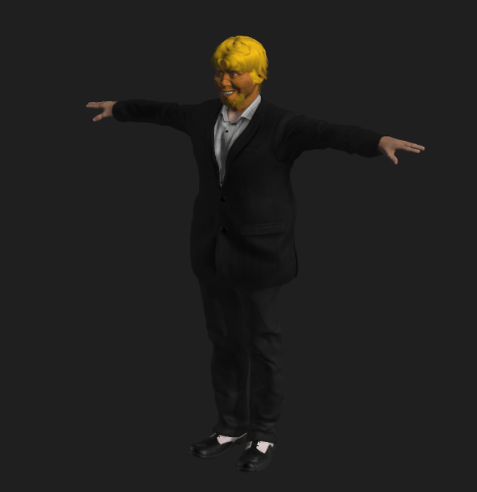

Figure 8, 9

To the left is the body of the first build of Donald Trumps’ character, he is very well dressed with his suit and shoes as a default design which can be changed by the player under character customisation at any time. To the right is Trump’s Faction flag, this will be help by Trumps allies, hung up at Trump held fortified areas and strongholds on free roam and shown on the game map to represent his control of the state or main city.

## Hillary and Bill Clinton:

Hillary and Bill are just as aggressive as Donald but they are aggressive in a different way, they use it politically to encourage other strongholds to yield rather than fight as well as to get some support from superpowers abroad. This means they don’t have as powerful weapons as Trumps’ allies but have access to a greater variety of equipment, armour and deployable like turrets and drones. They also have knowledge of the country given to her from Bill when he used to be in power meaning she can find collectables and secret entrances to some areas.

Hillary and Bills traits:

* Politically Aggressive towards enemy positions
* Minor Influence Abroad
* Negotiation skills
* Access to rare armour
* Access to deployable equipment
* 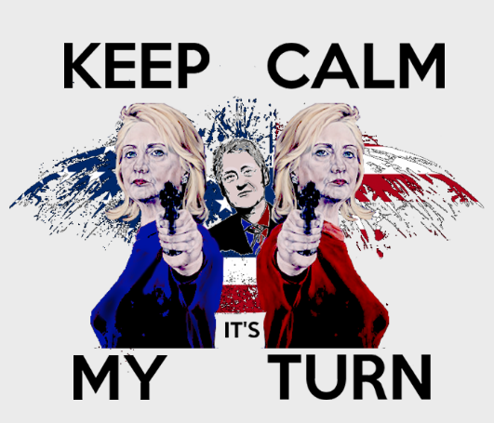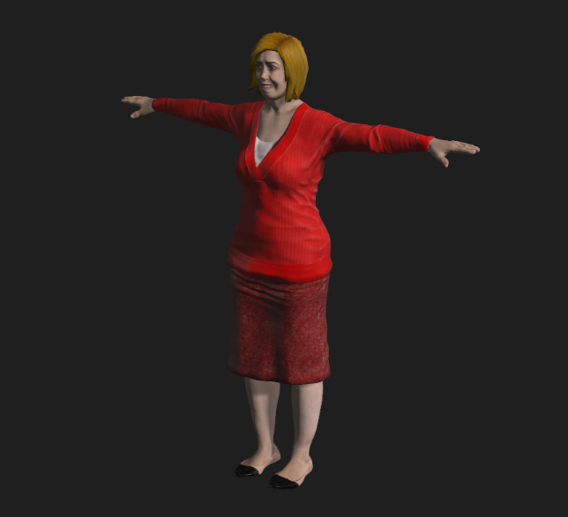Can find secret entrances and collectables

Figure 0, 11

To the left is the body of the first build of Hillary Clinton’s character, she is in a very respectful dress and work heels as a default design which can be changed by the player under character customisation at any time. To the right is Clinton’s Faction flag, this will be help by Clintons allies, hung up at Clinton held fortified areas and strongholds on free roam and shown on the game map to represent her control of the state or main city.

## Barack & Michelle Obama:

Barak and Michelle are not nearly as aggressive as the Clinton’s or Trump, but they do have the support of the healthcare aspects of the country as well as very strong skills in negotiations and caring for fallen and wounded enemies, citizens and allies.

This means that Barak hasn’t got access to very powerful weapons but has a lot more health in battles as well as access to deployable health assets to help allies.

Barack & Michelle traits:

* Standard weaponry
* strong survival skills
* Very strong negotiation skills
* Willing to help any American regardless of beliefs
* Deployable health assets
* Extra resource based missions
* Extra negotiation based missions
* 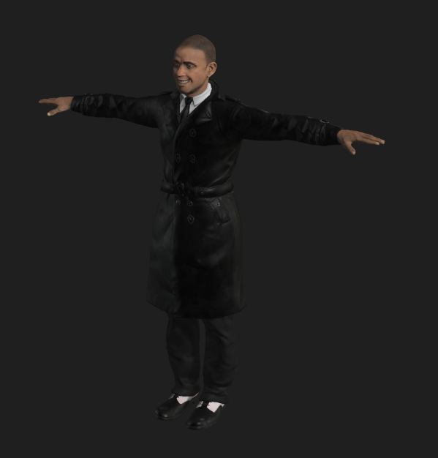Major International relations with other superpowers

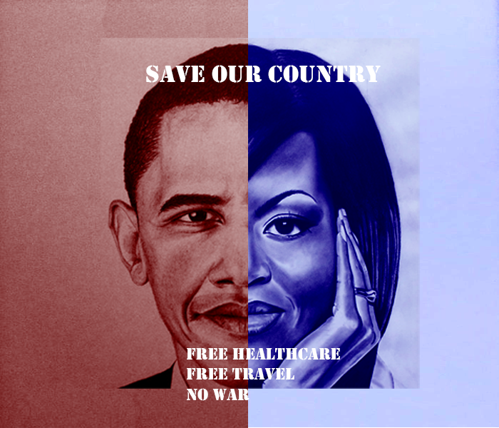

Figure 12, 13

To the left is the body of the first build of Barack Obama’s character, he is in a suit overcoat as a default design which can be changed by the player under character customisation at any time. To the right is Obama’s Faction flag, this will be help by Obamas allies, hung up at Obamas held fortified areas and strongholds on free roam and shown on the game map to represent her control of the state or main city.

# Non-Playable Characters (NPC’s):

### Secret Service:

The secret servicemen and women are the president’s personal army equipped with high tech, powerful and modern equipment. They are capable of defending strongholds very well but due to the lack of armour and direction they are not recommended to be used for assaults. They are also very expensive to recruit and maintain, they can only be recruited by the presidents character Donald Trump. They are able to be recruited from anywhere and can provide Trump with great cover for his escape if necessary. Base designs are shown in figures 14 and 15.

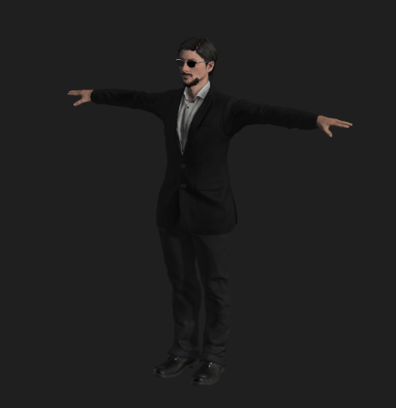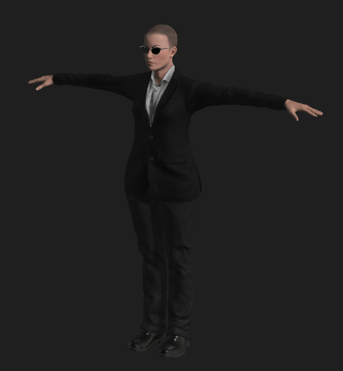

Figure 14, 15

### City, State and Citizen Based Militia:

City based militia can be found in major cities across America where they class themselves as their own independent militia from the state they are in. these militia can consist of standard American women and men, retired police officers, non-professional soldiers and deserters. These soldiers are perfect for the player’s character to hold onto strongholds in cities and states captured during gameplay. State Based militia are exactly the same as city based except they have a greater variety of recruits and can be called upon when the player is assaulting an enemy stronghold in the state they are in. Citizen Militia are equipped with the same equipment but wear their own clothes over army issue. Base design are shown below in figure 16 and 17.

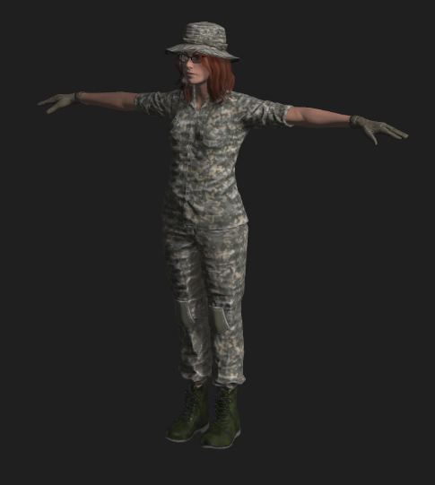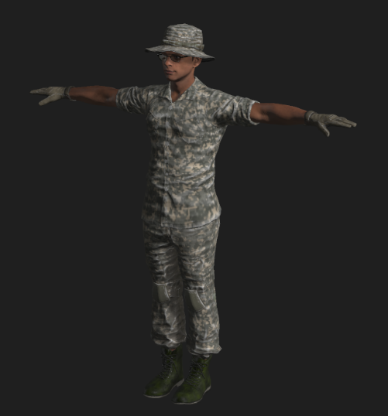

Figure 16, 17

### National Guard Soldiers:

National Guard soldiers are dotted around American states in their base of operations. They can be called in to assist the player at any time but depending on how they are influenced in that state or city they may be with or against the player character beliefs making them less effective. They will be armed with military based weapons which can help the player a lot against the likes of a Trump stronghold. Figure 18 and 19.

### Mexican Border Police:

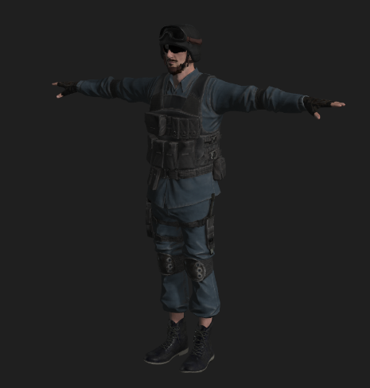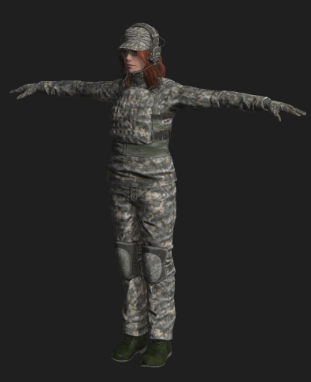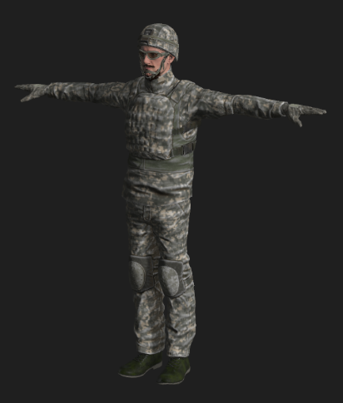The Mexican border police are all based along the wall that Trump has built to separate America from Mexico. They are all heavily armoured with strong weapons and very hard to negotiate with. However, they will never venture into America and also have some lightly guarded areas along the wall that the player can exploit in order to escape as Trump. If the player wishes to try and shoot their way through they will need a lot of followers and weapons to do so. Figure 20

### American Police:

Figure 0

Figure 18, 19

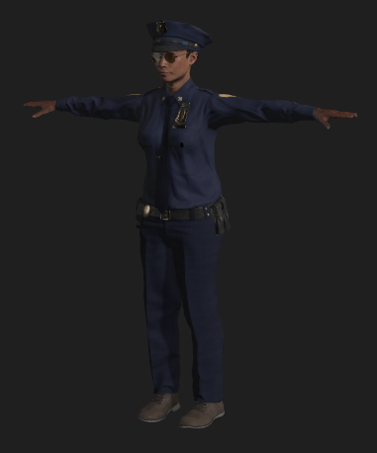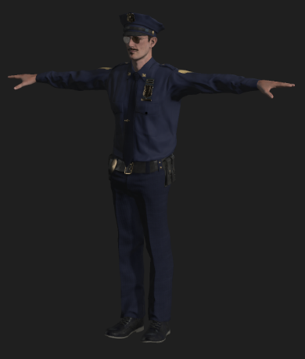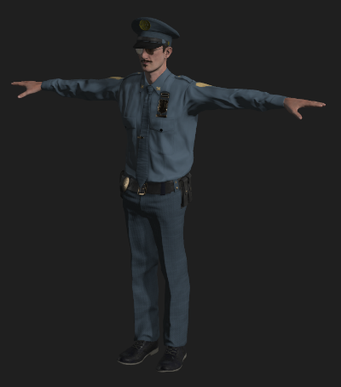The American Police are not that much more powerful than the militia but they are very well organised and when recruited by the player to help they are most effective in street battles and door to door raiding. They are also cheap units and can be very effective in numbers. Figures 21 to 23.

Figure 21, 22, 23

### Mercenaries:

Mercenaries can be recruited by any player at any time for a cost in influence, currency or weapons. The players can be anywhere on the map to purchase them to help fight battles offensively or defensively. The drawback to these soldiers is they can be bought out by the opposition before or during a battle causing the player to have to fight them too. To help prevent this they have traits and if their loyalty starts to fall the player is warned so they can deal with them.

# Player Character Customisation

## Beginning of the Game:

At the beginning of the game the player get to customise their characters clothing. They will have access to all sections around the body (upper, middle, lower body and feet). They won’t be able to change any facial or body features till later into the game and can be earned as a reward for missions. These features are shown to the player as “locked” so they cannot be selected.

On the customisation menu screen they can distinctively tell which type of clothing is where by showing them different icons relating to the clothing section they chose. For example an image of hats is head, glasses are facial accessories, shirt is upper body and trousers are lower body.

They can also change the colour and design of the clothing items they chose after progressing past the clothing selection menu. The new features can then be applied to the player’s character in the pause menu once earned or bought. The icons are shown on the right on figure 24.

Upper Body Customisation:

* Selection of hats
* Selection of scarfs
* Selection of glasses

Middle Body Customisation:

* Selection of shirts
* Selection of jumpers
* Selection of jackets
* Selection of bags and handbags

Lower Body Customisation:

* Selection of trousers
* Selection of shorts
* Selection of dresses & skirts

Feet Customisation:

* Selection of high heels

Figure 24

* Selection of trainers
* Selection of boots and shoes

## During Walkthrough of the Game:

During the game the player can unlock the features and clothing locked at the start of the game. They can do this by completing side missions or activities given to the player by NPC’s or by clues such as audio recordings or articles found in main missions or free roam.

Once the player completes the mission or activity this will unlock that feature and if they wish to they can change their character appearance on the pause menu. These rewards include the colour of the features such as hair and eye colour, clothing and accessories.

The customisation of the character does not given any buffs, traits, advantages or disadvantages for the player’s character, this is simply to allow the player to personalise the character.

# Gameplay:

## Sequence of play after Intro:

Once the player has completed the introduction level to the game they are then introduced to the rest of the game world where there are lots of different cities and states under different influences and beliefs. They are then guided to the next state and depending on who the player’s character is will determine what the next mission is. After the completion of the first side mission or activity the player unlocks several more side missions and activities to complete. The state or city tells the player there are a number of these missions that need to be completed in order to progress through to the main mission and storyline. This method is to help encourage players to do side missions and activities during free roam.

From here it is then the player’s choice where to go next and in what order they complete the side missions and activities across the map. Players have the opportunity to earn rewards from these missions depending on their difficulty and what they must do; rewards are also determined by the enemies they have to fight. The player can only complete the main story missions in a linear order, it doesn’t matter where the main mission is played.

## Different Scenarios:

In the missions and activities the players won’t always be fighting enemies, due to the nature of the game scenery there are elements of survival required for the player’s allies to concentrate on too. Depending on whom the players character is will determine what missions they are recommended to complete. Survival missions will include scavenging for resources, finding and stealing from convoys, looting abandoned areas, research and discovery, intelligence gathering, exploration, negotiation and propaganda. All of these missions and activities helps the player gain control of the city or state and earn bigger rewards. There are also areas of interest where the player can find resources such as medical equipment and clothing without having to earn it. Figure 25, 26.

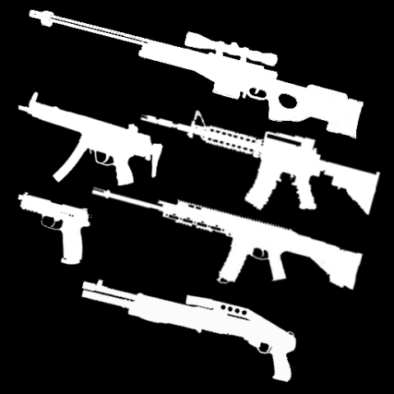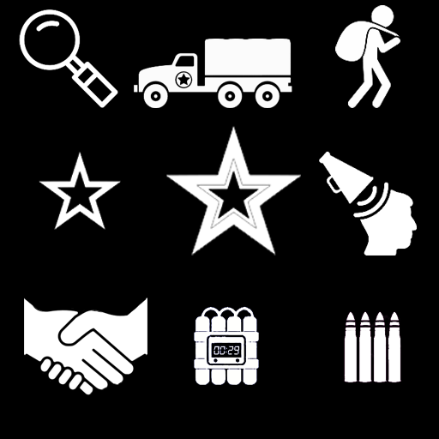

Figure 25, 26

## Collectables & Pick Ups:

During walkthrough of the campaigns the players can come across collectables such as intelligence and articles that help the player understand the backstory to the game (years of 2016-2020) and what happened in these years as well as predicted enemy movements. They can also find custom items specific to the character they are playing as for example spray tan for Trump and goggles for Hillary Clinton, these items cannot be earned by can be bought in the in game store.

So the players can find these items they will be guided visually with distinct sounds. These items will be ringing constantly much like a phones ringtone as well as highlighted in a clear primary colour making it visually obvious to the player when found. Below in figure 28 is an example.

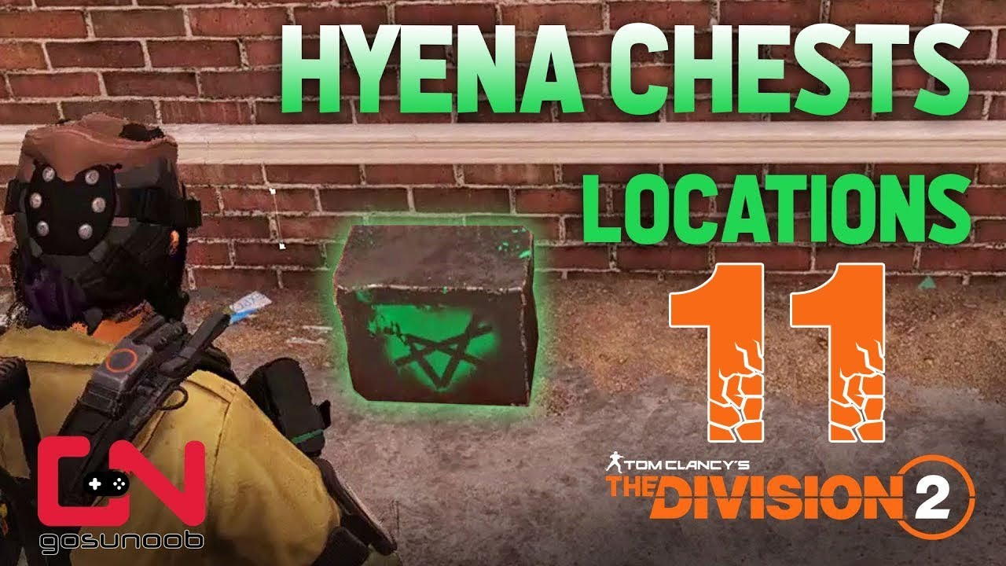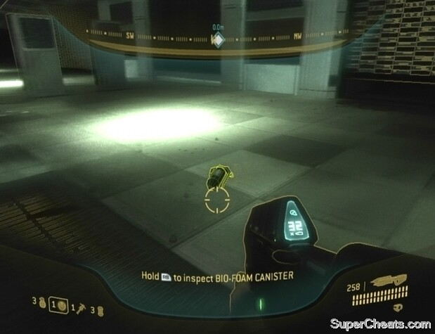These items will also be labelled on the players HUD to what the item is or if it’s a randomised it will displayed as a crate with a clear design or label to make it clear to the player this is a collectable. Below in figure 27 is an example.

Figure 27, 28

# Game World:

## Game World Map:

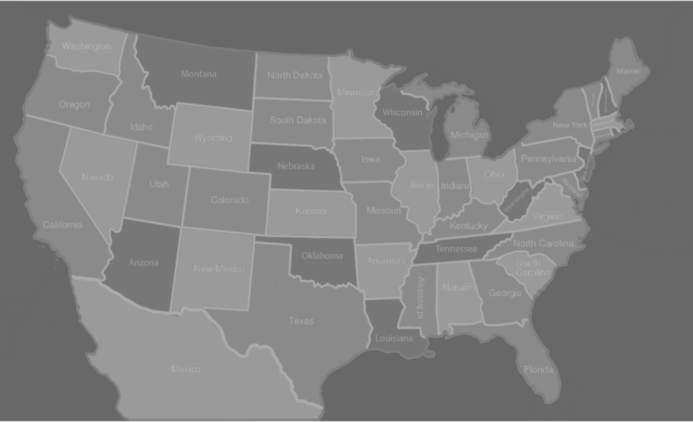The player’s world map will be located under the pause menu during gameplay. The players’ character will visualise this action by looking down onto their wrist watch. Once the map has been selected they will be in a bird’s eye view of their current location and the nearby environment. Using the left joystick and “a” or “x” buttons for console or left mouse click for PC the players can then move there cursor around the explored areas of the game world and can set destinations to missions, activities or any area of the map they wish to go to. They can also use the right joystick or middle scrolling button on the mouse to zoom in and out of the game world to help the players find more activities or missions to do in order to earn enough influence in that state or city to progress. This also helps provide some opportunities for exploration. Figure 29

Figure 29

## Features of World Map:

There will be several different features for the player to discover, understand and strategize whist progressing through the game. The three main features to look out for are the players political rivals last known location, position of missions, what their requirements are to unlock and lastly the influence in each state and city across America. The players can then decide what they would like to do with the map information provided to them.

Using the map the players can try to discover where their political rivals are within the game by completing intelligence research or discovery side missions and activities. These missions will help the player discover and unlock sections of the game world before their political enemies. They can also use the map to see where new missions and activities have been unlocked due to successfully completing previous missions and activities.

Using the map the player can learn the political status of nearby states and cities so they can learn the amount of work that will be required to obtain the state or city so they can earn the rewards. Some states may be leaning towards the player’s character politically meaning they have to complete less missions and activities against easier opposition. This also means if the player wishes to acquire a state or city that’s politically against their character they will need to complete more missions and activities against harder opposition. However, if the player leaves a state or city unattended for too long they could lose power and therefore the rewards it brings, meaning the player has to go back to get the state or city back before progressing. Figure 30, 31 below is examples of weapon icon rewards.

## Environments and Locations:

The player will have to travel across all of America especially playing as Barack since his goal is to save America so undoubtedly will have to explore different environments, these will include dessert, rural, overgrown areas, forests, snowy mountains and sparse locations. Also in all these environments there will be elements of destruction, poor sanitation and maintenance due to the nature of the game. This will help the player adjust to similar scenes and environments they may encounter during gameplay.

## Story Related Locations:

During the main story of each of the characters campaigns the player will experience every different type of scenery in the game at least once. They can experience the environment and have the opportunity to admire and learn how to fight in this type of environment. Each different type of location will be tied into each other with the use of intelligence reports and collectables found during each main mission, the player will be guided to one or two of these but other will need to be searched for. This also allows the player to understand their character a lot more and what happened to America pre-civil war. This then leads onto the next main mission in wherever the audio footage suggests the player go to.

In some of these locations there will be elements of the past shown such as locations for Trumps and what people thought of them through these intelligence findings. Having the player understand what the character has done in each location will invoke feelings about their character and why depending on who they are playing, everyone wants to murder or support him or her within the game.

## Character Specific Locations:

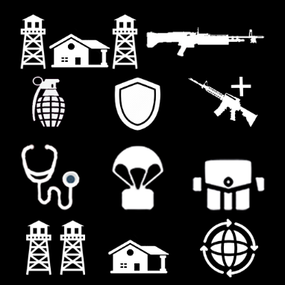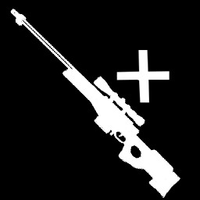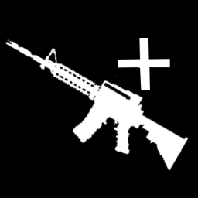Character specific missions and activities all relate to the player characters traits when they start the campaign meaning they can develop their advantages over their enemies to give them an edge in different scenarios. Trumps being weaponry has access to light machine guns (LMG’s), Hillary has access to superior explosives and armour equipment and Obama has superior medical supplies and political skills worldwide. Shown in figures 32 and 33.

Figure 30, 31

Figure 2, 33

## Things found in Different Environments:

### Desserts:

Desert vanish, living stones, acacia trees, various types of cacti and rocks, barns, gates and fencing

### Rural:

Selection of storage objects, living luxuries, vehicles, buildings and construction, newspapers and magazines, seating areas, gardens, bins, bollards, lamp posts, pathways, roads, bridges, boats

### Overgrown Areas and Forests:

Various types of trees, poisonous plants, tree trunks, ponds and rivers, rocks, leaves and waterfalls.

### Mountains and Snowy Terrain:

Rocky surfaces, rocks and boulders, stripped down trees, snow, manmade pathways, and ridges.

### Sparsely Populated:

Farmland, gates, fencing, barns, cottages, lakes and rivers, plantation, vast open spaces.

# Audio and Soundtrack Features:

## Character Speech:

Character audio is dependent on which character it is and what scenario the character is in at that specific time in the game. There is going to be a lot of swear words and other forms of bad language being used by the players character during bad scenarios, when the character is wounded and near death. There will also be positive audio being used by the player characters such as winning a battle or seizing an enemy stronghold.

Player characters will have good comments of audio when something goes their way such as successfully defending a stronghold or killing or capturing a main enemy during the campaign depending on who they are playing as. These comments don’t have any political consequences towards the characters position; it is more to add to the feel of a battle environment for the player.

Characters will also have small comments when they rank up during the game to emphasize the levelling up, players can unlock different comments to then be used during different scenarios. If the player does not wish to earn audio features they can buy it in the in game store.

## Different Scenarios, Winning or Losing:

During gameplay the player will encounter different types of scenarios and requirements to complete or escape that scenario. The player will be given clues with small soundtracks on where to go or avoid. Most of these sounds will be heard during main and side missions, during boss and specialist enemy encounters, saving allies or saving a friendly stronghold from assault. They will also be used during discovery and exploration missions to help the build-up of the situation.

When the player fails a side mission or activity but hasn’t died due to it being propaganda looting activities they will be hear a defeat type soundtracks to try and get the players to attempt it again. Once a player completes an activity or mission they will be greeted with a completion type audio soundtrack whist their rewards are being given out on their HUD/ screen.

### Weaponry:

There will be different types of audio fitted to different weapons which the player has access too such as handguns, SMG’s, Assault Rifles, LMG’s, Handguns and Snipers. Also the audio of the player switching a weapon or deploying a weapon will be heard too. Handheld explosives such as grenades will have distinct different sounds depending on what type of grenade it is. Attached explosives such as C4 or Dynamite will have much bigger and louder explosion soundtracks especially if you’re playing as Hillary and complete a successful explosives mission.

## Environments:

As stated before there will be several types of environmental settings included in the game with different types of rewards based around that area such as shotguns being mostly earned in southern America. This is to help encourage the player to explore the different environments and adjust to the scenery they see. The different environments and the audio what will be included are shown below:

### Deserts:

In this environment the player can expect to hear a lot of dry wind taking sand and rock with it, the rustling of very few plants and the sound of nothing to peak the players curiosity. Having very little sounds in these areas are designed to keep the player alert and the suspense high.

### Rural:

In these environments the player can expect to hear a lot of man made noises such as weapons being fired, construction related, weather related and the wildlife that live in the city such as birds, dogs, cats and rats. There will also be sounds coming from vehicles such as car horns and shutting of doors or windows. There will be a lot of explosions too. These are areas where most battles and deaths occur.

### Overgrown Area and Forests:

In these environments players can expect to hear a lot of wildlife living in the trees and bushes as well as a lot of wet wind and rain to go with it. The weather can be harsh and unpredictable in these environments.

### Mountainous and Snowy Terrain:

In these environments players can expect to hear a lot of cold wind as well as a lot of snow and ice distracting the player visibility. There will be quite a lot of forests in these environments which also brings audio too.

### Sparsely Populated:

In these environments the players can expect to hear very little expect a lot of wildlife living in farms and occasionally extreme weather conditions. There may be some sounds of manmade fighting too.

### Collectables and Intelligence:

When a player is near a collectable during free roam or a mission they will hear a bleeping sound and as they get closer to the collectable the bleep gets louder and louder until they find it. This bleep also get quieter as they move away from the collectable, this to indicate to the player they are going the wrong way.

# Game Experience:

## Player First Impressions:

When the player chooses their character, customises them and finishes the first two introduction levels they will witness a political civil war which has completely divided America and turned it into a war zone. As they witness for the first time the destruction of America I want the player to feel sadness with no hope of preventing another major civil war from happening.

I also want them to feel frustrated and angry for what has happened whist being determined to fix everything during gameplay throughout the game. I also want a small amount of laughter and humour about the character choice they have chosen.

## Development of the Player Character:

Depending on whom the player choses at the beginning of the game, I would like the player to empathise with the American people despite as their nation is in the state it is in due to politics. I want the player to understand their character as well as the others through intelligence and collectables during gameplay and let them decide who to be empathetic towards.

As the player progresses with their character I want them to understand why the enemy is their enemy, what they could do if they were the character in the game and how they can fix what has been broken. I want the player to feel a sense of urgency towards their main goal in the game to save, control or escape America.

## Story Cut Scenes:

At the beginning of the campaign there will be a backstory cut scene which sums up what happened just before the 2021 election and describes the foundations of why America is in this state. The player will then witness how their character reacts to the publication of negative news about them just before the election campaign started.

During the game the player will witness short cut scenes showing them their allies capturing or losing strongholds, requests for help, informing them of nearby resources etc. With this information the player can then chose to help, gather or look into the information given.

Main story cut scenes will be much longer and will be shown to the player as they progress through the main story-line of each character. These scenes can also be acquired through gathering intelligence found around America but won’t be as long nor significant to the main story.

# Gameplay Mechanics:

## Core Mechanics:

### Movement:

Walking and running to get across the map to get to a desired location or destination due to there being no form of public transport such as trains or busses. They’ll also be jumping and sliding over objects and manmade explosives or avoid natural hazards.

### Transportation:

The player will be able to call for transportation to get to a certain area in a state or even to another state of city from where they are located. As trump they’ll receive a secret service convoy and as Clinton and Obama, a military convoy which will then take them to their desired destination. They will also be a fast travel option which the player has to earn during gameplay and is accessed through the pause menu screen on the map.

### Weapons:

Aiming, shooting, reloading and throwing will be required to have a weapon with them at all times and have to be ready to aim and shoot anything whist making sure they have enough ammunition to venture outside of the allied strongholds and throw explosives such as grenades at enemies.

### Combat:

Rolling and going behind cover must be used if the player’s character is getting low on health and is near death, can be used to avoid certain weapons such as rocket launchers. Deployments and reinforcements to be able to use the special abilities which the character has and the player can use to increase their chance of success

## Interacting Mechanics:

### Elevation:

The option of ladders and ropes to climb up and down in order to reach different floors or platforms of buildings. Also platforms to jump onto to get to different levels on a building to gain an advantage.

### Collection:

Collecting loot crates and pickups to open or stolen from other factions across the map as well as opening audio and visual intelligence found. Being able to pick up ammo, explosives and weapons from dead enemies.

### Communication:

Being able to communicate with allies in allied as well as enemy territory, also to talk to NPC’s in need of help or has information which can help your main goal in game.

## Economy Mechanics:

### Game Currency:

Players will be able to earn in game currency for completing missions and activities, they’ll earn bonus currency depending on their performances. Currency can also be earned from loot crates found or earned during the campaign.

### Trading and Selling:

Store and shops will be present in areas the player has control of and will be found in stronghold or fortified areas. They can use the in game currency to purchase different types of equipment such as weapons and armour and equip to their character. They can also trade equipment they already have and don’t want any more to get discounts on equipment they want from these stores.

## Encounters:

### Manmade:

Manmade traps and hazards such as tripwires, explosions, motion trackers, alarms which the players are recommended to avoid if they are not detected

### Natural:

Naturally made such as sink holes in deserts, tarmac due to poor maintenance and forest due to ponds and rivers. Overgrown areas causing limited visibility and broke off vegetation such as logs crushing them as they fall from hills.

# Achievements:

### Performances:

During gameplay the player will be able to unlock achievements during missions and activities. They’ll be able to get them for having outstanding performances. These achievements are aimed towards players who want to get all the achievements in the game.

### Character Change:

Some achievements can only be achieved by using a specific character in the game, this will help encourage players to replay the campaign as different characters. Players will be notified when they complete an achievement with a notification on their screen HUD and if opened with a description what they have done to get it, this is for the players that don’t know how they got it.

## Bonus Material:

### Equipment:

Player’s performances in missions and activities will give them a selection of blueprints they can earn; after enough are collected they can construct the legendary equipment or weapon they’ve been trying to get. Alternately they can complete missions or activities and keep replaying them to earn currency to then buy it in an in game store. These weapons will cost a huge amount of in game currency causing the player to consider spending real money for it.

### Replay Ability:

When a player has completed the campaign and want to pay again they will have the opportunity to import there characters rank, weapons and currency so then they can continue to rank up their character as well and improve their equipment and weapons by playing the same missions. Also importing there character gives them the opportunity to play missions and activities that didn’t exist during the first walkthrough. This is to stop the player getting bored during gameplay.

# Monetization:

## In Game Store:

### Currency and Buffs:

Players will have the opportunity to purchase in game currency and boosts or buffs which will help them purchase whatever they want in an in game store or give them an edge in certain missions. These will be a very cheap, around £2-5 but ensure there are lots of items to sell.

### Equipment and Weapons:

If a player wishes to not grind on the game for hours and hours in order to earn the rewards to get a legendary weapon or equipment they will be able to purchase it instead. These items will aimed to cost £5-20 depending on the weapon they want, how rare it is, what they player has to do in order to earn it and the rank they have to be to get it.

### Customisation:

Player characters customisation at the start of the game are mostly locked but as the player progresses they will be able to earn more clothing items to include on their character, however if the player does not wish to wait they can purchase clothing items for a small to a high price of £3 to £15 depending on what the clothing item is and if they are getting a bundle deal.

There will also be seasonal customisation assets available for the relevant time of year such as a Christmas hat over the Christmas period. These can then be purchased by players after the seasonal holiday if they didn’t get it. Players can also buy the characters special pick-ups such as goggles and spray tan rather than trying to find it in gameplay.

## Downloadable Content (DLC):

### Environmental:

On the main menu players will have the option to play in different world scenes or environments as well as all new roasters of characters to choose from and a whole new storyline. For example playing as a Cartel in South America with each opposing cartel having different goals to export there goods or a Brexit scene where players can run for prime minister and try to bring Brexit through in Brussels. This will be a campaign extension costing around £15, this is to try and keep players playing the game and not get bored.

### Characters:

Players will have the option to purchase different political characters and storylines to follow in the main campaign in America. These characters will relate to the other minor parties across America and there goals will be much harder to reach, this is to try and add some challenge to heavily experienced players. Players can also purchase characters from the same parties as Donald, Clinton and Obama such as Michelle and Bill. They’ll follow the same storyline but with these characters.